More String Formatting

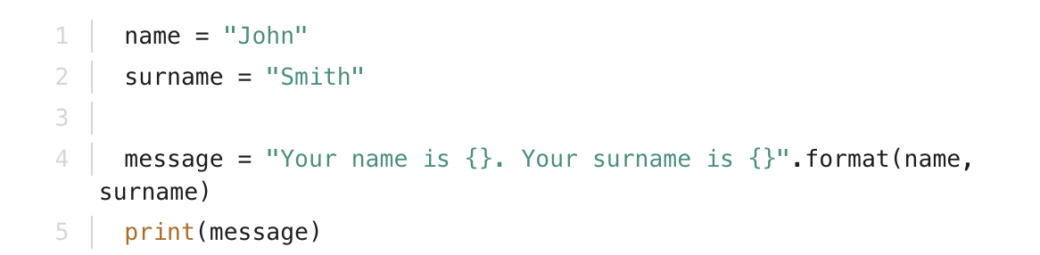
There is also another way to format strings using the "{}".format(variable) form. Here is an example:

Output: Your name is John. Your surname is Smith

